CS4433 LMS – Use Case Model
Tokelo Motsopa · Student No. 202322664 · CS4433 Software Engineering · National University of Lesotho
The model has 4 actors and 16 use cases, with three written in full: Submit assignment, Mark submission, and Moderate and release marks. Requirement IDs (FR, NFR) refer to the SRS.

1. Actors
Actor | Description | Main use cases
Administrator | Manages accounts, departments, courses and enrolment | UC-02, UC-03, UC-04
Lecturer | Creates assignments, grants extensions, marks work | UC-05, UC-06, UC-09, UC-16
Head of Department | Moderates and releases marks in their department | UC-10, UC-16
Student | Submits work and views released marks | UC-07, UC-15
Staff User (abstract) | Generalisation of Lecturer and Head of Department for shared use cases | UC-16
All four actors perform UC-01 Log in.

2. Use Case Diagram
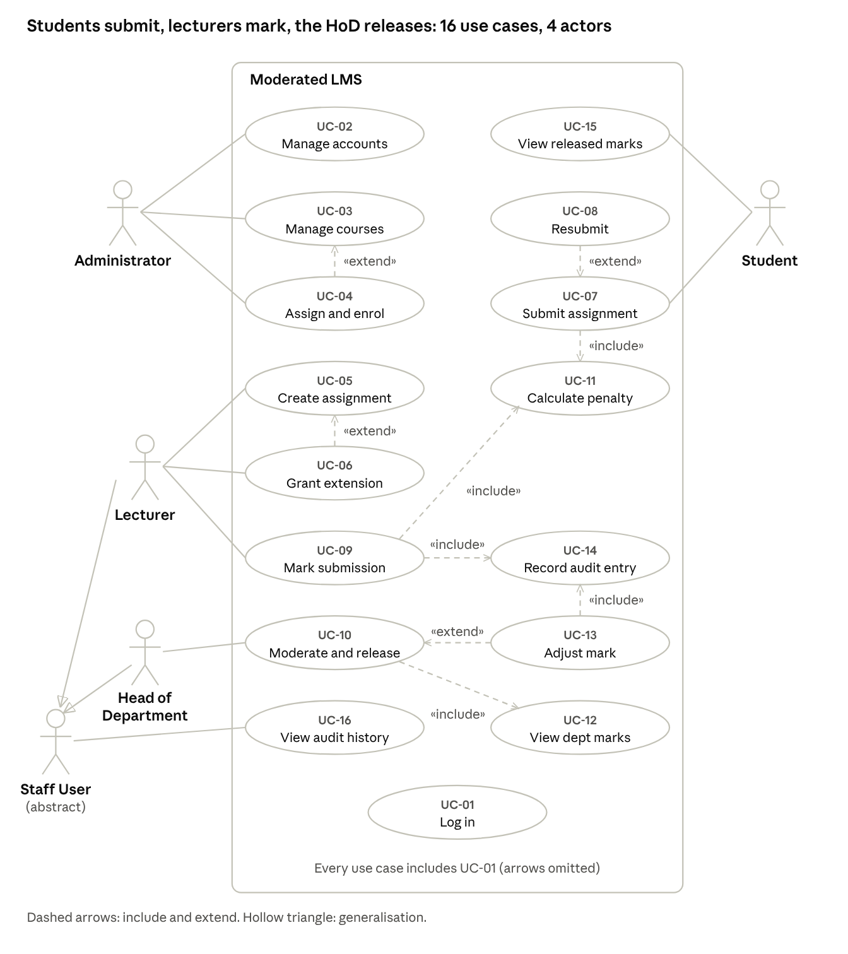
use case diagram · 4 actors, 16 use cases
Lecturer and Head of Department specialise the abstract Staff User, which owns UC-16. Every use case includes UC-01 Log in; those arrows are omitted for clarity.

3. Use Case List
ID | Use case | Actor | Relationships | Requirements
UC-01 | Log in | All | Included by every other use case | FR-01, FR-02, FR-23
UC-02 | Manage user accounts | Administrator |  | FR-03, FR-24
UC-03 | Manage departments and courses | Administrator |  | FR-04
UC-04 | Assign lecturers and enrol students | Administrator | Extends UC-03 | FR-05
UC-05 | Create assignment | Lecturer |  | FR-06
UC-06 | Grant extension | Lecturer | Extends UC-05 | FR-11
UC-07 | Submit assignment | Student | Includes UC-11; extended by UC-08 | FR-07, FR-08, FR-10, FR-21
UC-08 | Resubmit assignment | Student | Extends UC-07 | FR-09
UC-09 | Mark submission | Lecturer | Includes UC-11 and UC-14 | FR-13, FR-19
UC-10 | Moderate and release marks | Head of Department | Includes UC-12; extended by UC-13 | FR-15, FR-16
UC-11 | Calculate late penalty | System | Included by UC-07 and UC-09 | FR-12
UC-12 | View department marks | Head of Department | Included by UC-10 | FR-14
UC-13 | Adjust mark | Head of Department | Extends UC-10; includes UC-14 | FR-15
UC-14 | Record audit entry | System | Included by UC-09 and UC-13 | FR-18
UC-15 | View released marks and feedback | Student |  | FR-07, FR-17
UC-16 | View audit history | Staff User | Lecturer and HoD specialise Staff User | FR-20

4. UC-07 Submit Assignment
Field | Description
Actor | Student
Trigger | The student chooses Submit for an assignment
Preconditions | The student is logged in and enrolled in the course; the assignment exists
Business rules | BR1: the effective deadline is the student's extension if one exists, otherwise the assignment deadline. BR2: a submission is on time if its time is at or before the effective deadline. BR3: the late penalty is applied at marking (FR-12). BR4: resubmission is allowed only before the effective deadline, and the latest version is marked.
Postconditions | The submission is stored with its time and state; earlier versions are kept; no mark is visible to the student
Main flow
- The student selects the course and then the assignment.
- The system shows the assignment details and the effective deadline.
- The student provides the work (text or file path) and confirms.
- The system validates the input (not empty, valid file, within the size limit).
- The system records the submission with a timestamp and sets the state to Submitted.
- The system confirms receipt and the time.
Alternative flows
- A1 Resubmission before the deadline: a previous submission exists. The system asks for confirmation, stores the new version as current and keeps the old one.
- A2 Late submission: the effective deadline has passed and there is no earlier submission. The system warns of the penalty (10% of the maximum mark per day, zero after 3 days), asks for confirmation and records the submission as Late.
Exception flows
- E1 Invalid or empty input: the system shows an error and returns to step 3.
- E2 Student not enrolled: the system denies access (FR-07).
- E3 Resubmission after the deadline: the system rejects it with an explanation (FR-10).
- E4 Database error: the system shows a message and rolls back, so nothing is partly saved.

5. UC-09 Mark Submission
Field | Description
Actor | Lecturer
Preconditions | The lecturer is logged in and assigned to the course; a submission exists in Submitted or Late (or Marked, for re-marking)
Business rules | The raw mark is between 0 and the maximum; feedback is mandatory; the penalty follows FR-12 from the effective deadline; final mark = raw mark minus penalty, never below 0, and 0 after day 3
Postconditions | The submission is Marked; an audit entry exists; the student sees nothing
Main flow
- The lecturer opens the submission list of an assignment.
- The lecturer selects a submission.
- The system shows the work, its time, the days late and the effective deadline.
- The lecturer enters a raw mark and written feedback.
- The system validates the input and calculates the penalty and final mark (UC-11).
- The system saves, sets the state to Marked and writes an audit entry (UC-14) with old value, new value and reason.
Alternative flows
- A1 Re-marking a Marked submission: the lecturer must give a reason; an audit entry is recorded.
- A2 The submission is already Moderated: the change returns it to Marked for re-moderation.
Exception flows
- E1 Mark out of range: error, return to step 4.
- E2 Empty feedback: error, return to step 4.
- E3 Lecturer not assigned to the course: access denied.
- E4 Database error: rollback and a message.

6. UC-10 Moderate and Release Marks
Field | Description
Actor | Head of Department
Preconditions | The HoD is logged in; at least one submission in their department is Marked
Business rules | The HoD sees only their own department; every adjustment needs a reason and an audit entry; only Moderated submissions can be released; release makes the mark and feedback visible to the student
Postconditions | Released submissions are visible to their students; audit entries exist for all adjustments
Main flow
- The HoD opens the moderation queue (Marked submissions in the department, by course and assignment) (UC-12).
- The HoD reviews each mark, its feedback and any penalty applied.
- The HoD approves the marks and the system sets the state to Moderated.
- The HoD selects Moderated marks and chooses Release.
- The system sets the state to Released and records the release time and the HoD.
- The system confirms how many marks were released.
Alternative flows
- A1 Adjust a mark (UC-13): the HoD enters a new mark and a reason; the system records an audit entry (UC-14) and continues at step 3.
- A2 Partial release: the HoD releases only some Moderated marks.
Exception flows
- E1 No Marked submissions: the system shows 'nothing to moderate'.
- E2 Attempt to release a submission that is not Moderated: rejected.
- E3 Adjusted mark out of range or no reason given: error.
- E4 Database error: rollback and a message.

